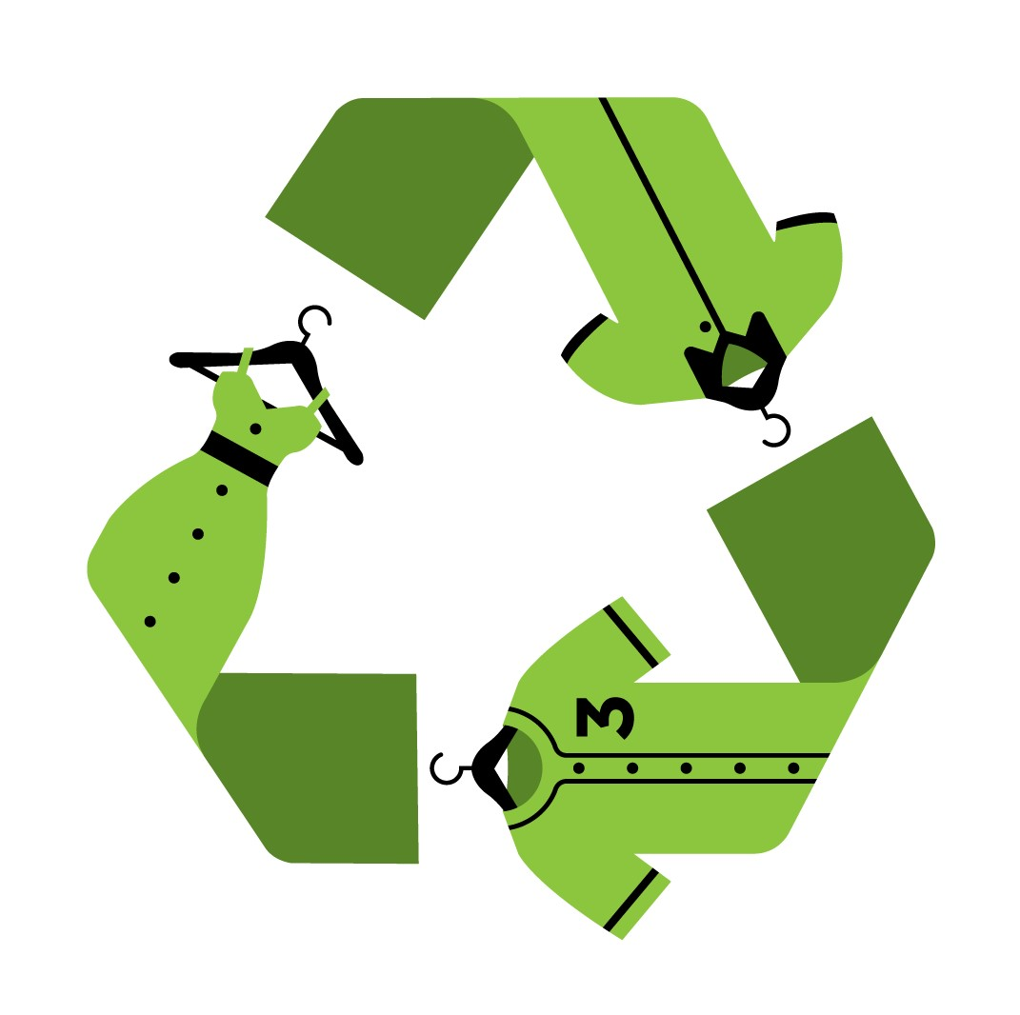
ACCEPTABLE ITEM LIST

NEW OR USED CLOTHING/HOUSEHOLD LINENS, BLANKETS, TOWELS, etc.
All items dry and not mildewed.
- OFF HANGERS
- UNSORTED
- PLACE IN TRASH BAGS OR BALED
- DRAPERIES AND CURTAINS
- LARGER PIECES OF FABRIC – Sq. Yd. or Larger
- Not accepted:
  - Small fabric scraps
  - Carpet, rugs
  - Pillow, cushions

PAIRED WEARABLE SHOES
- SHOES EITHER TIED, RUBBER BANDED OR PAIRED IN SAME BOX
- USABLE SHOES/WORK BOOTS: No soles peeling, broken heels or holes
- NO WINTER INSULATED BOOTS, HOUSE SLIPPERS, METAL SPIKES, ROLLER BLADES, ICE SKATES, SPIKED HIGH HEELS LONGER THAN 2”
- PLACE IN BOXES, PREFERABLE LESS THAN 50 LBS.
- GAYLORD BOXES ON PALLETS IF VIABLE
BELTS
- FUNCTIONAL
- BOXED OR BAGGED

PURSE/HANDBAG/BACK PACKS
- FUNCTIONAL (No Suite cases)
- BOXED OR BAGGED - GAYLORD BOXES ON PALLETS IF VIABLE

TOYS
- FUNCTIONAL
- SOFT OR HARD
- LESS THAN 12”
- SINGLE TYPE TOYS….NO MULTI PIECE; IE. ,RACE TRACKS, BOARD GAMES AND PUZZLES
- HARD TOYS IN BOXES, SOFT TOYS IN TRASH BAGS

WHERE DOES IT GO?
Either reused in export markets or recycled into wiping rag or fiber markets.

-Member of Missouri Recycling Association (MORA), www.mora.org

-Partial funding through the St. Louis-Jefferson Solid Waste Management District and the Missouri Department of Natural Resources , www.swmd.net

3340 MORGAN FORD RD
ST. LOUIS, MO 63116
314-865-0303
paul@remainsinc.com
FACEBOOK: REMAINS, INC
www.remainsinc.com
Paul Wight

